**Developing Login Page In Microsoft PowerApps**

In PowerApps, we can develop Login Page using TextBox, Text Input, Button, and Screen Controls.  
  
**Login Page**  
A login, logging in, or logging on, is the entering of identifier information into a system by a user, in order to access that system (e.g., a computer or a website or an app).  
  
A login generally requires the user to enter two pieces of information, a username and a password. This information is entered into a Login Page.  
  
A username is also referred to as an account name. A password differs from a username. It is intended to be kept a secret.  
  
Here, we will learn how to create a simple login page in Microsoft PowerApps. In this login page, I have used text boxes, button, and text input tools for the design part. Coding on each of the tools can be written separately as per user choice and functionality.  
  
Follow the below steps to work with DropDown in PowerApps.  
 **Step 1 Log into PowerApps**  
  
After downloading the PowerApps from Windows Store, here, we need a Microsoft related organization’s Office 365 ID or (MSDN, Microsoft, Skype, Office 365 etc.,), to login with it.  
  
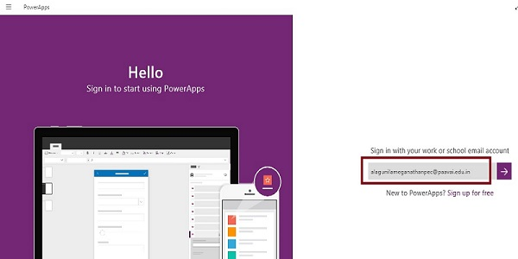  
  
**Step 2 Create a new app in PowerApps**  
After Login, we will see the Dashboard. There, click on the New button.  
  
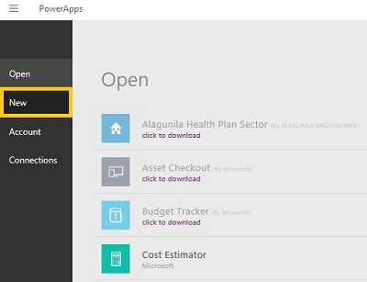  
  
**Step 3**  
Choose the Blank App.   
  
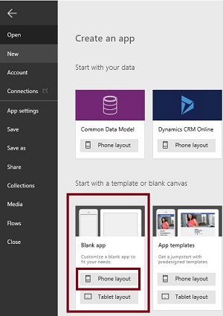  
  
**Step 4 Design the app**  
  
Now, let's start designing the app. In the left side, we can see the individual screens for adding our data. In the right side, we see the list of Layouts. At the top, we see the formula bar. There, you see the Properties of the screen that you select. In the right side, we see the Add Data Source to add the External data Source.  
  
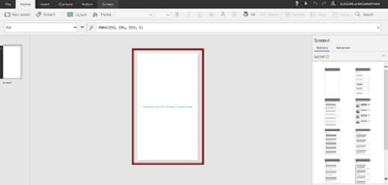  
  
**Step 5 Designing the Login Page**  
Design Text Box in the Login Page.

1. Go to the Insert menu, then Controls, and drag the Text Control.  
     
   PowerApps
2. Drop the Text Control on the screen and Change the Text Property as UserName.  
     
   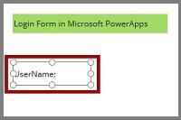
3. Similarly, place another Text Control and Change the Text Property as Password  
     
   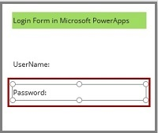

**Design Text Input Box in the Login Page**

1. Go to the Insert menu, then Text, and drag the Text Input Control.  
     
   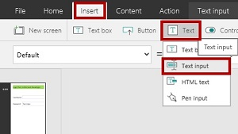
2. Drop the Text Input Control on the screen.  
     
   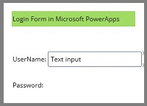
3. Similarly, place another Text Input Control.  
     
   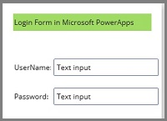
4. Rename the Second Text Input control to Password  
     
   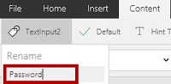
5. Select the Password Text Input control and set the mode to Password  
     
   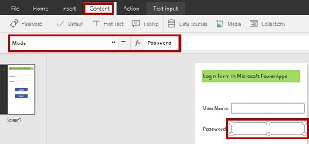

**Design Button control in the Login Page**

1. Go to the Insert Menu, then choose Button Control.  
     
   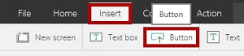
2. Drop the Button Control to the screen and change the name to Submit.  
     
   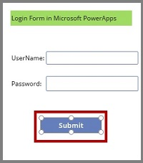
3. Rename the Control to Submit  
     
   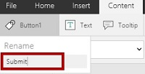
4. *Add Coding*  
   Select the Button Control and add the following coding.  
     
   *Coding*  
   If (Password.Text= "Hello" , Navigate(HomePage, ScreenTransition.Fade))  
     
   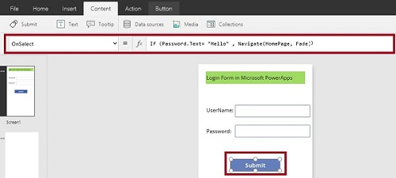
5. Place another Button Control.  
     
   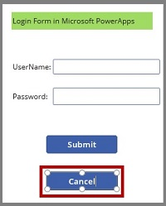
6. Rename the control to Cancel  
     
   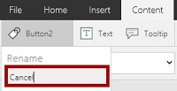
7. *Add Coding*  
   Select the Cancel button and add Exit() to OnSelect Event.  
     
   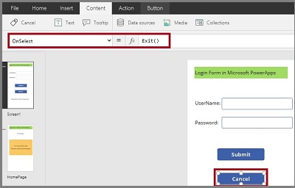

**Design Text Box control in the Login Page**

1. Go to the Insert Menu, then choose Text, and drag the Text box Control.  
     
   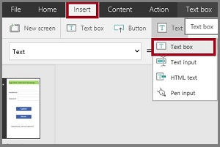
2. Drop the Text box Control to the screen.  
     
   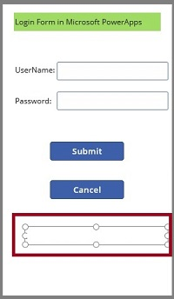
3. *Add Coding*  
   Select the Text box Control and add the following coding.  
     
   *Coding*  
   If(Password.Text = "Hello", "Your Password is Correct", "Please Enter Correct Password")  
     
   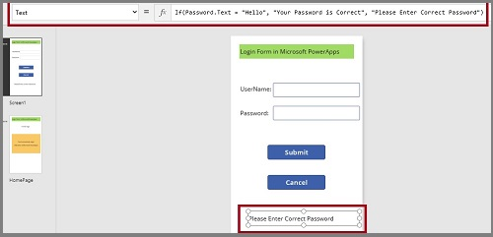

**Step 6 Designing the Home Page(Next Page)**  
If the Username and Password is correct, the Home Page will open  
  
**Create a new Screen**

1. Go to the Insert menu and click on the New Screen.  
     
   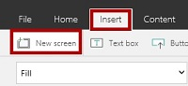
2. Rename the Screen to HomePage.  
     
   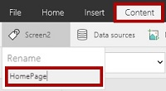
3. Place the Text Box.  
   Go to the Insert and drag the Text box control.  
     
   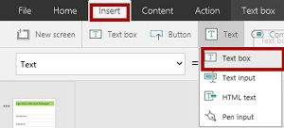
4. Drop the Text box and add the text.  
     
   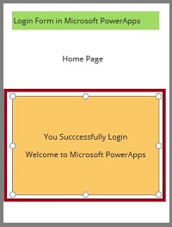

**Step 7**  
Run the app  
  
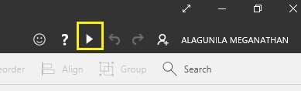  
  
**Output 1**  
  
Main Screen  
  
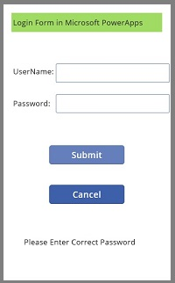  
  
**Output 2**  
  
Enter the correct UserName and Password.  
  
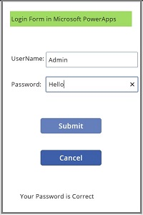  
  
**Output 3**  
  
Click on the Submit button.  
  
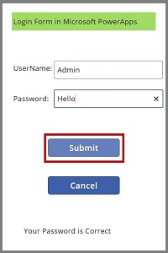  
  
**Output 4**  
  
It will open the HomePage.  
  
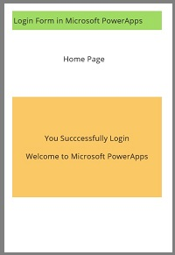  
  
**Output 5**  
If the password is wrong.  
  
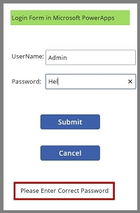  
  
**Conclusion**  
  
I hope you understood how to develop the Login Page in Microsoft PowerApps and how to run it.